CN ASSIGNMENT 4

Name: Himanshu Kumar Roll no. : 2022215

Q1)

1. What is the maximum expected value (theoretical) of throughput (in Mbps)? Why?

**Maximum Expected Throughput**: The theoretical maximum throughput is determined by the bottleneck link in the network, which in this case is the link between N0 and N1 with a bandwidth of 10 Mbps.

**Reason**: In a TCP connection, the throughput is ultimately limited by the link with the lowest bandwidth. Since the link between N0 and N1 has a higher bandwidth (10 Mbps) compared to the link between N1 and N2 (7 Mbps), the maximum expected throughput is limited by the 7 Mbps link between N1 and N2. Therefore, **the theoretical maximum throughput is 7 Mbps**

1. How much is Bandwidth-Delay-Product (BDP)? Express your answer in terms of the number of packets.?

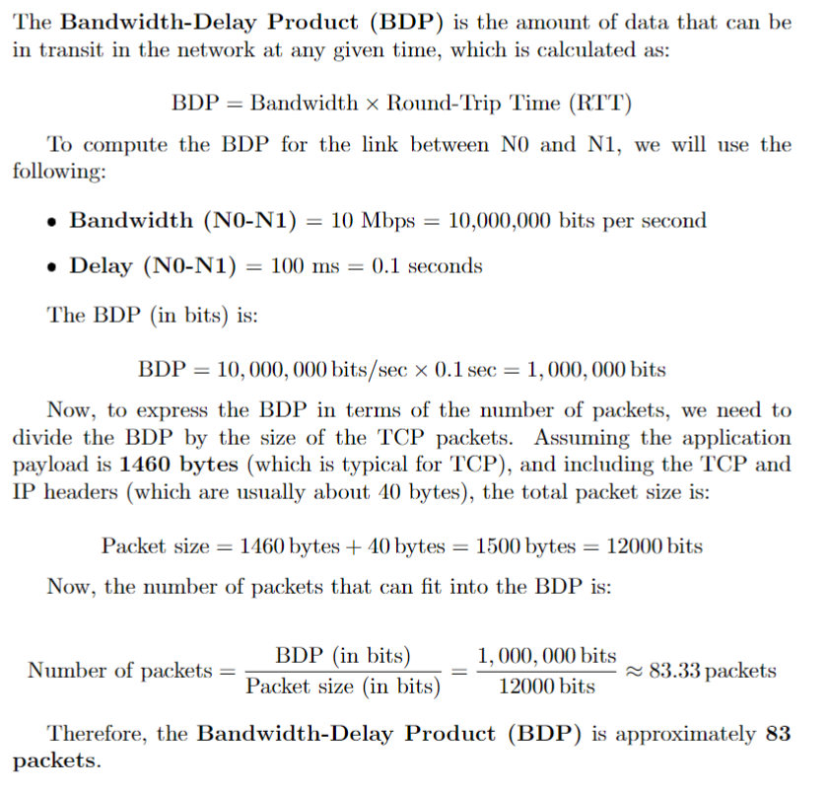

If we don’t consider header than,

Therefore, the **Bandwidth-Delay Product (BDP) is approximately 86 packets**

1. What is the average computed throughput of the TCP transfer?

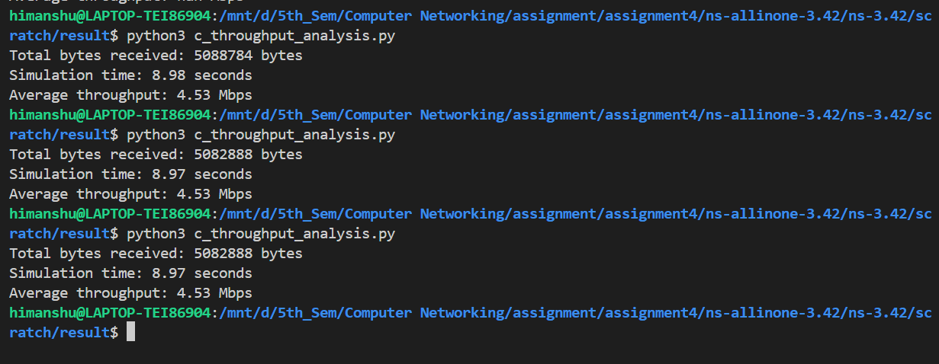

1. Is the achieved throughput approximately equal to the maximum expected value? If it is not, explain the reason for the difference.?

**No, the achieved throughput is not equal to the maximum expected throughput.**

**Achieved Throughput:**

**The achieved throughput is slightly less than the theoretical maximum.**

**Reason for Difference:**

* **Packet drops due to limited queue size at N1.**
* **TCP overhead (e.g., retransmissions, acknowledgment delays).**
* **Losses from non-buffer-related factors (default loss rate of 0.000001)**

1. Plot Congestion Window (CWND) with time

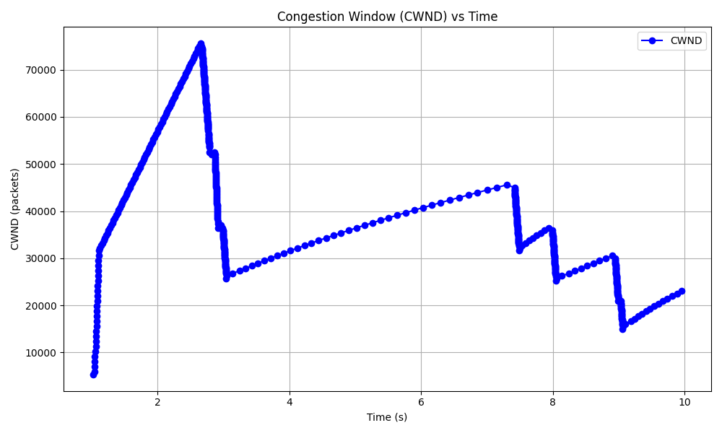

1. Plot queueing delay with time

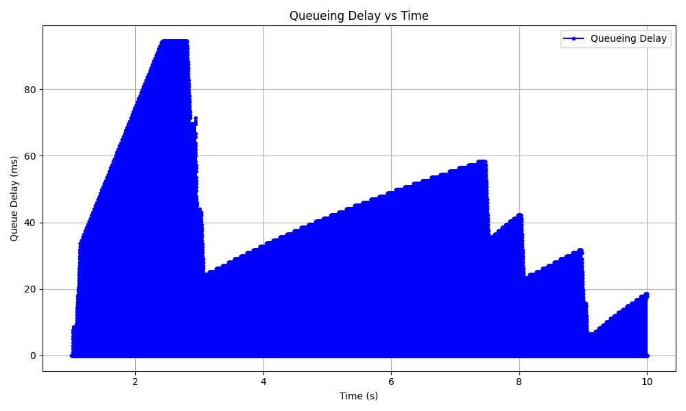

1. Are the plots in 1(e) and 1(f) related?

Yes, the **Congestion Window (CWND) plot** and the **Queueing Delay plot** are related.

* The **CWND plot** represents the sender's view of the network's capacity to send data. As CWND increases, the sender can push more data into the network.
* The **Queueing Delay plot** shows the time packets spend in the buffer at node N1 before being forwarded. As the sender's window increases, it can send more data, which might fill up the buffer, leading to higher queueing delays.
* High CWND values (indicating high sending rates) will likely result in longer queueing delays if the network bottleneck occurs (e.g., congestion at N1).

The queue length and delays tend to increase as the congestion window increases, and the TCP sender's rate of sending data exceeds the available capacity on the link.

**Relationship:**

* When CWND increases, more packets are injected into the network, causing higher queueing delay.
* Queueing delay stabilizes once CWND reaches a steady state.

Q2)

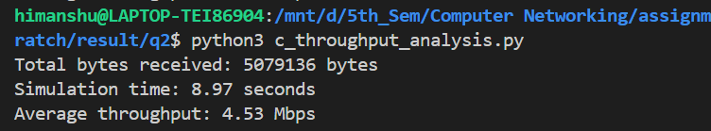





we may see a different CWND growth pattern due to the increased buffer size. The larger queue size allows for more data to be buffered in the network, which may lead to the

TCP sender having more data to send without waiting for acknowledgments, potentially allowing the CWND to grow faster initially. However, this might also cause longer delay periods when the buffer fills up, leading to congestion and slower growth afterward. But here we see same graph , due to large number of packets.

Insights to Gain from Comparing the Plots:

Impact of Larger Buffer Size: A larger buffer size may lead to an increased

CWND more quickly, especially during the slow start phase, as packets can be

buffered while waiting for acknowledgments. However, the system might become

more prone to congestion, which can result in a decrease in the rate of CWND

growth as the buffer fills up.

Queueing Delay: When the queue size is increased, you may notice higher

queueing delays as the network may experience bursts of traffic due to the larger

buffer size. This could be observed as spikes in the queueing delay plot, which

corresponds to packets waiting longer in the queue before being dequeued.

Efficiency and Buffer Overflow: The larger buffer size may lead to better

utilization of network resources in terms of throughput, but it can also lead to

inefficiency and higher delays when congestion occurs, especially if the buffer

overflows and drops packets.

Q3)

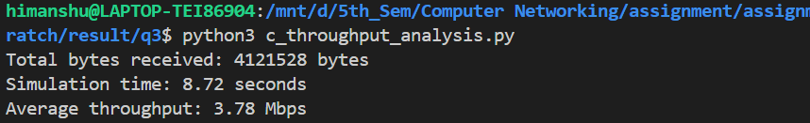

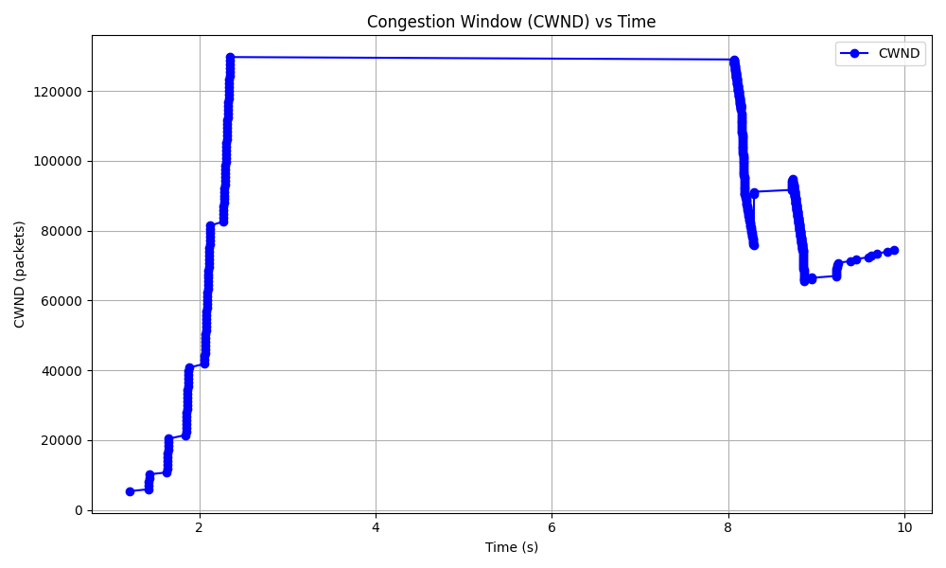

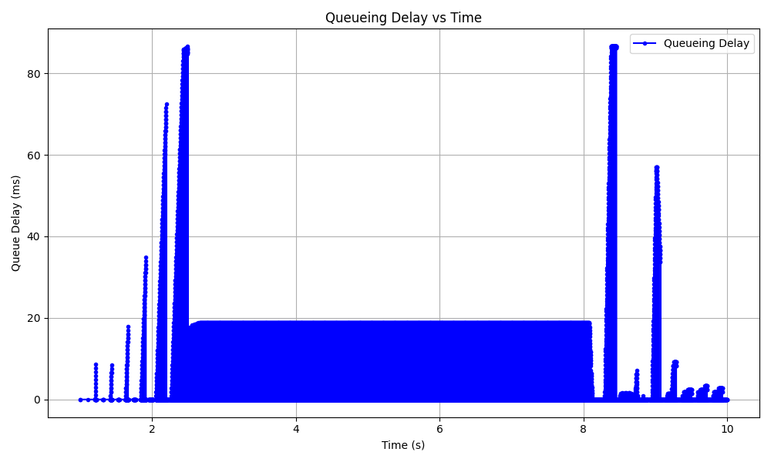

In Q.1 (with default parameters), the queueing delay may have been lower compared to Q.3 (with bandwidth increased to 10 Mbps and delay increased to 100ms). The larger bandwidth allows the sender to transmit data more quickly, but the increased round-trip delay can cause longer periods of packet waiting in the queue.

Insights:

1)Impact of Larger Bandwidth and Delay: Increasing the bandwidth (to 10 Mbps) allows for more data to be transmitted, but the increased round-trip delay (100ms) means the sender has to wait longer for acknowledgments. This can cause packets to accumulate in the queue, leading to higher queueing delays.

2)Effect of Buffer Size: Larger queues might result in more packet buffering, which increases queueing delay, especially when the transmission rate exceeds the rate at which the receiver can process packets.

3)Network Congestion: In both Q.1 and Q.3, network congestion can cause the queue size to increase, but with the larger bandwidth in Q.3, we may observe bursts of data being sent quickly, filling the queue and causing higher delays.

In conclusion, increasing both bandwidth and delay can lead to higher throughput but may also cause increased queueing delays, especially when the network is heavily utilized. Balancing bandwidth, delay, and buffer size is essential for efficient network performance.